Assignment 3

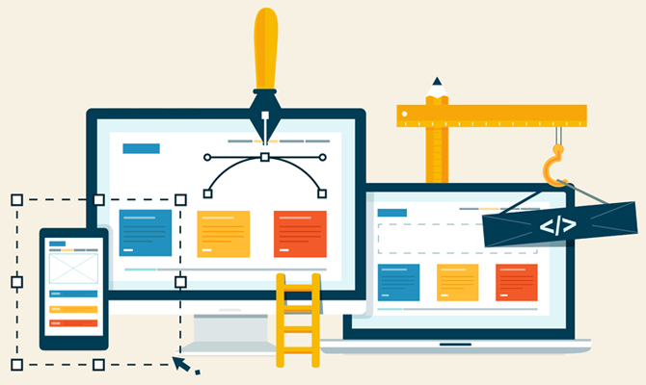

A3: Website Creation.

U28

Ridwan Ishola | 339554 | P5|M2|M3|D3

Link to my website:

192.168.1.78:8080/app1/

**Note**

Please note that the website is placed on a local server (which is my laptop) therefore would only be accessible whilst my laptop is switched on.

Task 1: create an interactive website to meet a client need.



Double-click to open

Above is my website, which is accessible when the link has been clicked. Additionally, my website has been placed on a server, therefore can also be accessible when the directory to the server has been written in the search bar. However, as I am using a local server, and hesitant on changing the settings of the server, the *domain name* to my website would be numbers- which is my IP address and then the port number that the visitors would use to access my website which is port 8080.

The Server that I have used to host my website, is the *Apache Tomcat server*. Below, I am going to be detailing how I have used this tool to successfully host my website and the additional steps I have taken to ensure that my website is accessible over the internet.

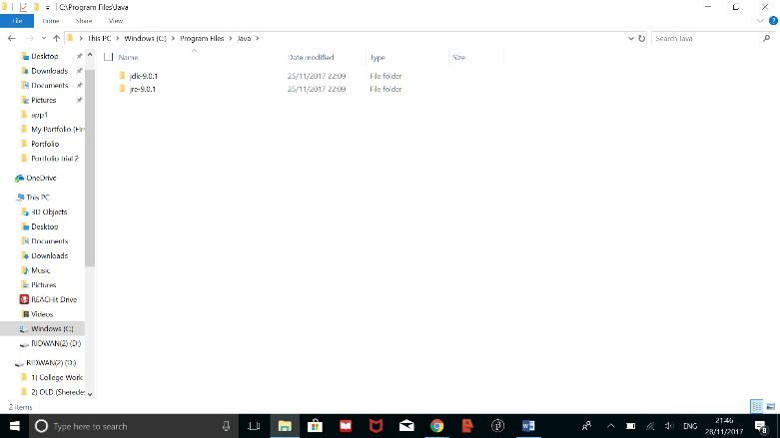

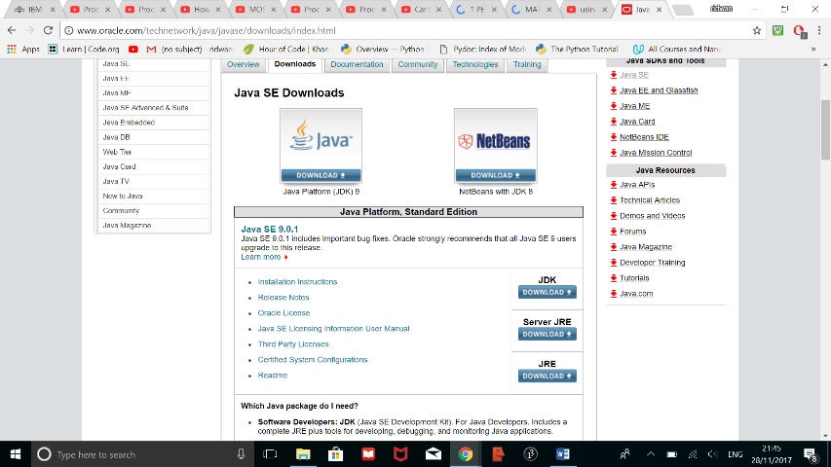

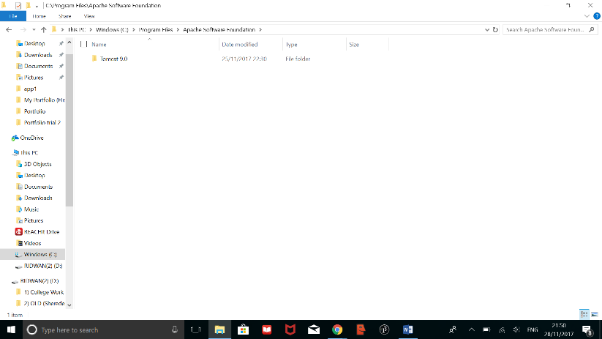To successfully install the Tomcat server, firstly, I had to install the Java JDK and JRE programs as these have the libraries and components that would be used by the Tomcat server. After downloading these programs, I then downloaded the program for the Server itself, as shown below:

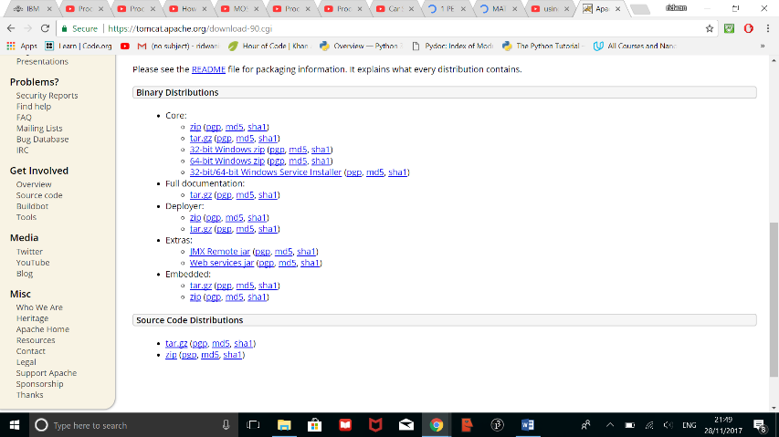

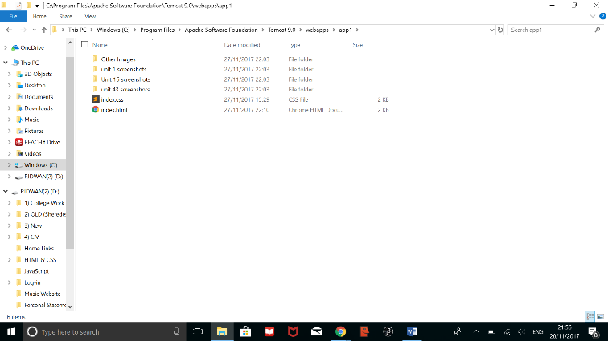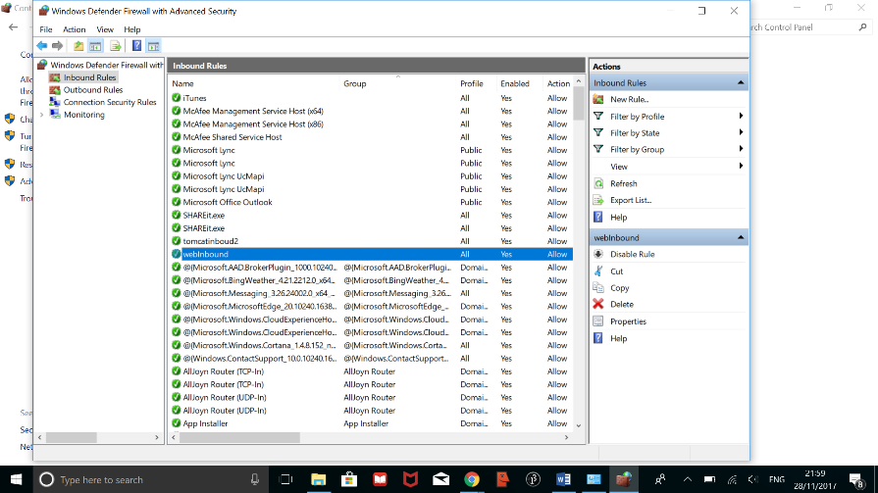When downloading the Apache Tomcat Server, I made sure to choose the *Windows Service Installer* as this version automatically detects what BIT size to download, and also includes the additional files with it. On download, I also made sure that the program is linked to the Java JDK program that was installed earlier as the server will utilise the libraries and components of the program.

To ensure that my website is hosted on the server, I had to upload all of the files that would be need for the website to function as designed. Additionally, I had to rename the first page that I want to load up first, “Index.html”, with the CSS accompanying it “index.css”. This was done so that the server could recognise what page to load up first.

Lastly, to make sure that my server accepts incoming traffic, I had to change the *firewall settings* in the control panel so that my computer accepts traffic that was coming through *port 8080*.

Content and Structure of my Website

**Index Page**

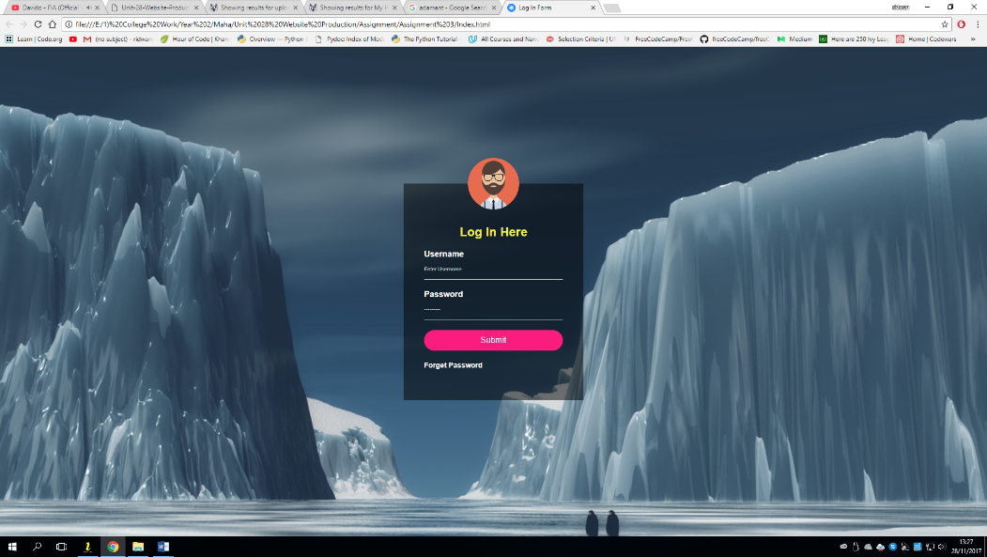

Login Input field

“Forget password link”

Background Image

Above is a screenshot for the *Index Page* of my website. This first page is the initial page that will load up when the user visits my website and was implemented to fulfil the criteria that was mentioned in the brief- of the portfolio requiring a login page. Additionally, it was implemented to add an extra layer of security to my website as only users with the correct log-in details will be able to access my website.

The two pages that link to this index page are: the Password Reminder Page and the Portfolio itself. The password reminder page can be accessed when the “*Forget Password*” link has been pressed and will link to where the username and password credentials are stored.

The portfolio itself, can be accessed when the correct login details have been submitted on the log-in page.

**Portfolio**

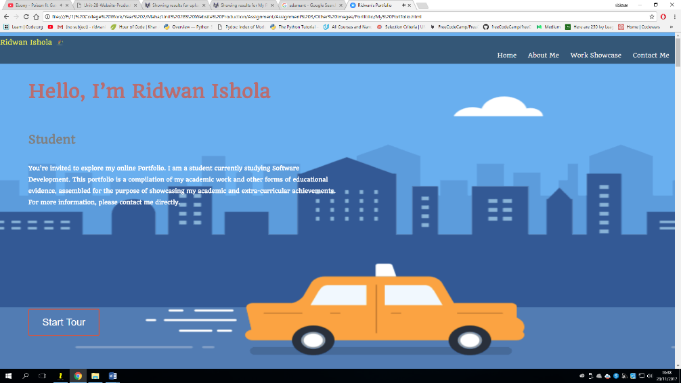

Welcome Text

Background GIF

“Start Tour” Button

Navigation Bar

The screenshot above shows the Welcome Page of my portfolio. The background on this page is a GIF. Initially, I planned on creating an animation to place as the background of this page, however, due to unforeseen complications with placing canvas’ as a background, I was forced to using GIFs instead of an animation as originally planned. Nevertheless, I have made sure that the GIF I have used in my portfolio is free and does not infringe any copyright laws- which is especially important as I will be publishing my website. To link to the next page, I have added the “Start Tour” Button.

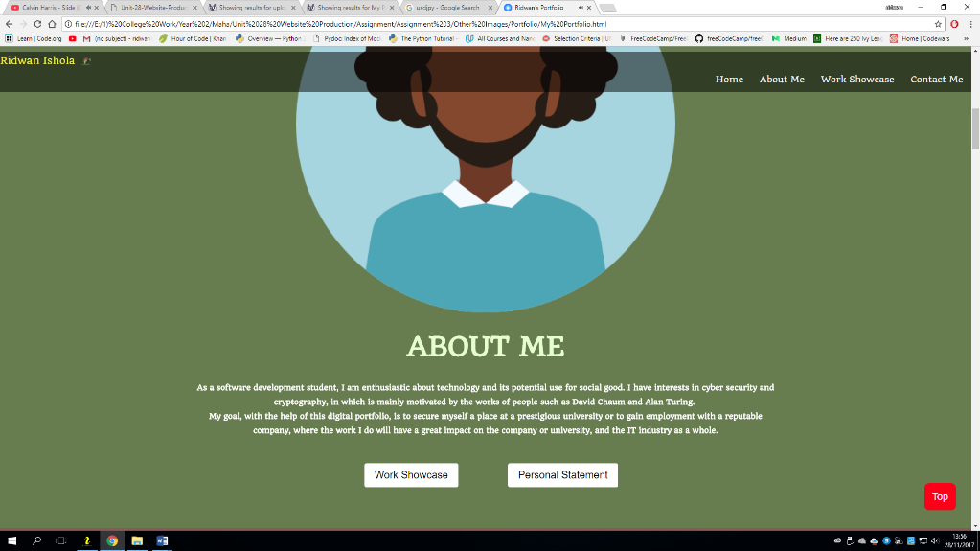

Image

Descriptive Text

“Scroll To the Top” Button

Work Showcase Button

Personal Statement

One continuous presence from the previous page is the *Navigation Bar*, which will still be present as the user scrolls through all of my website. I have achieved this feature by making the positioning of the navigation bar in CSS “fixed”. This allows this navigation bar’s position to be the same as the user scrolls through my website.

As I wanted minimal text on this page, I have included my *Personal Statement* in a downloadable form. This was achieved by linking its file path to the “personal statement” button and then placing the html “download” function inside of this link. Clicking this button will then download my personal statement in word document form.

In addition, as a means to improve the ease of navigation, I have included a scroll to the top button. I have chosen to implement this on my website as it improves the ease of access to the top, and is a quicker method of returning to the top of my webpage than scrolling back up.

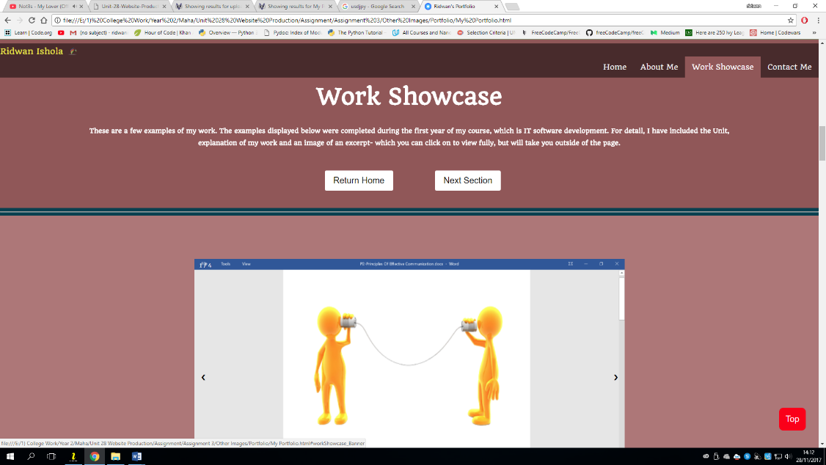

Buttons

Descriptive text

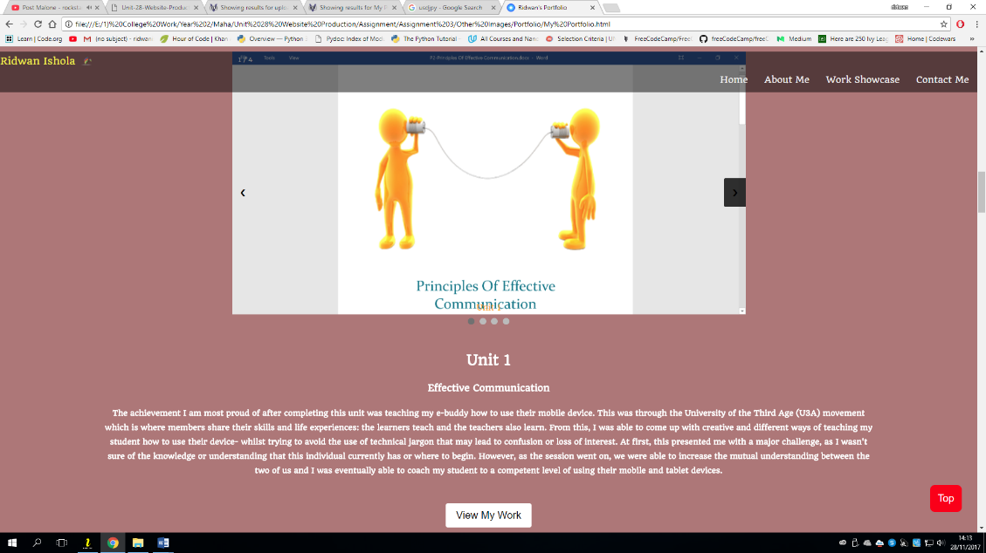

Description of the unit

Image Gallery

Button

On this page, I have included an image gallery that includes images of work I have done. To view the rest of the images, the user would have to click on the next or previous arrows, which are on either side of the images. For detail, I have included a very brief description of what the image shows. Below this image gallery, I have written a description of activities I undertook whilst studying this unit. After this, I have included a button that links externally to Dropbox, which is where I have stored all of the documents pertaining to the unit.

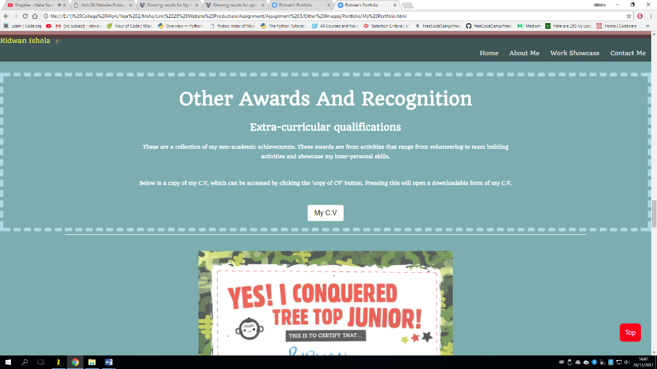

Description of what the section would be about

My C.V

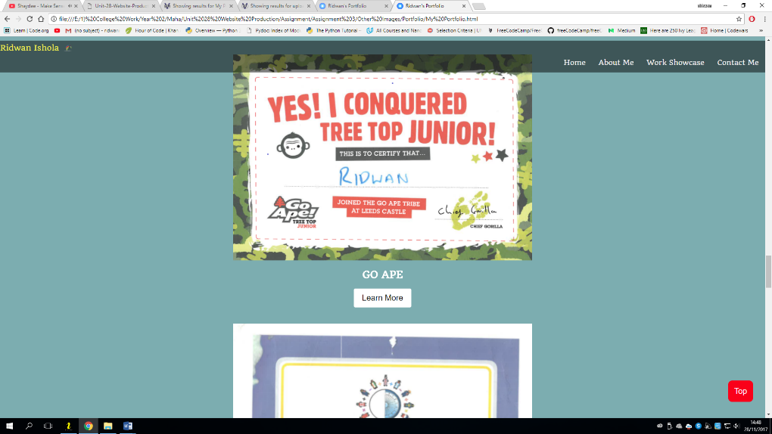

Image of E.C activity

Brief Description

Learn More Button

This section of my portfolio holds the evidence for all of the extra-curricular activities that I have undertaken. Above this section, I have included my C.V which can be downloaded by clicking on the C.V Button. I have chosen to include this on my portfolio website so that my audience (future employer and university) have evidence of my inter-personal skills in a real-life scenario. As part of this page, I have included my C.V. in a downloadable format instead of a screenshot as it gives my audience the ability to print it and inspect it more closely.

Additionally, below each of the images on this section, I have included a “learn more” button, that will redirect the users to the website of the provider of the awards.

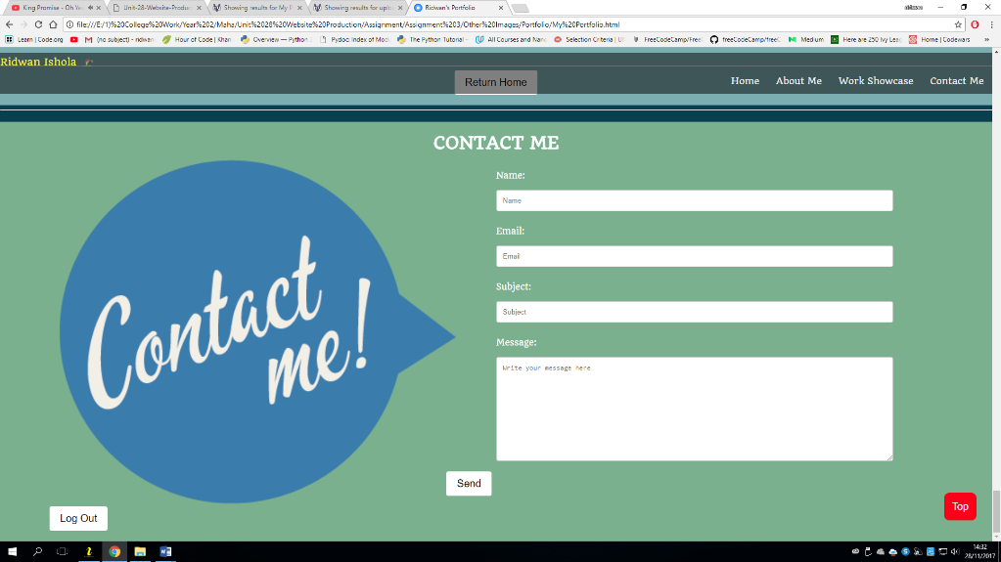

Contact form

Log Out button

Send Button

The final section of my portfolio is the “Contact Me” section. This section is how those who visit my portfolio would be able to contact me. As mentioned in the initial design of my website, the contact me page would be linked to my actual email address, so that I will be notified whenever a user has contacted me. I have achieved this by linking the send button to my email, so that when the user presses the button, their mail app would load up and the content of the input boxes would be automatically copied into the text field of their email.

I have chosen to reveal minimal details about myself- such as my phone number or social media accounts as I am aware that not all of the visitors on my portfolio will be my intended target audience. Instead, I have opted to include a message box, where the user would type in any messages that they would like to send me, then a ‘send’ button where the user can then send these messages. Although this would not prevent those that are not my target audience form contacting me, I have chosen this method as it doesn’t reveal any personal detail of mine and still allows anyone who visits my website to contact me.

Lastly, on this page, I have included a Log Out button, which links to the login/index page.

Tools and Techniques Used When Creating my Website

Transitions

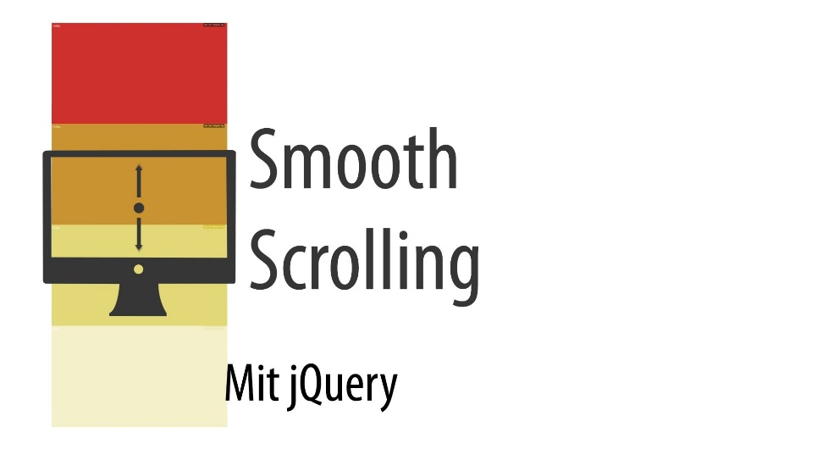Transitions are an interactive feature of websites that are triggered when the user moves from one page to the other. There are several types of transitions, which include:

* Horizontal: Page glides along a horizontal axis.
* Vertical: Page glides along a vertical axis.
* Cross Fade: Page fades into view.
* Out-In: Page disappears before new page appears in its place.

On my portfolio, the transition type that I have chosen to use is the smooth-scroll which makes the page glide to its destination when another page had been pressed. I have chosen this type of transition, over other types of transitions, such as the cross-fade transition, as it makes the user aware that they are moving out of a page and going to another through the animation- in which the other transition types do not replicate.

Interactivity

Interactivity in relation to websites means that websites should be designed in such a way that users should be attracted and be engaged on the site. As this is when a website can reach its users effectively. It is for this reason that I have chosen to implement some form of interactivity on my portfolio- as it is more effective when my target audience (future employer and university) are fully engaged through out my website, making them more likely to go through the whole website because of this.

I have made my website interactive through the use of various types of animations. One type of animation that I have used is the smooth scrolling animation above- but more importantly, I have included a GIF on my homepage. This gif was used as the background and I believe that adding this into my portfolio has made it more effective as it will be more eye-catching- making the target audience (future employer and university) more likely to see the rest of my website.

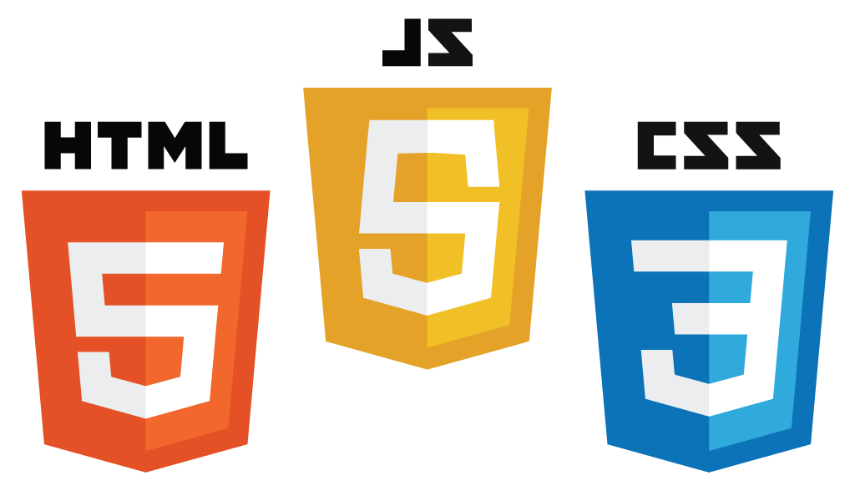Software Used

To create my portfolio, I have used HTML to structure the pages and CSS to style the content of my page. I have chosen these two languages as they are the most widely used languages to create websites and are compatible with most browsers. In addition, I have used JavaScript to provide better interaction with HTML- making my website more interactive and keeping them on my site for longer. One way I have used JavaScript to provide better interaction to HTML, can be seen in the gallery in my Work showcase section. JavaScript was used in this case to provide better interaction with the images, by enabling the view all of the images by pressing the next or previous buttons.

Services Used

**W3C Validation Service**

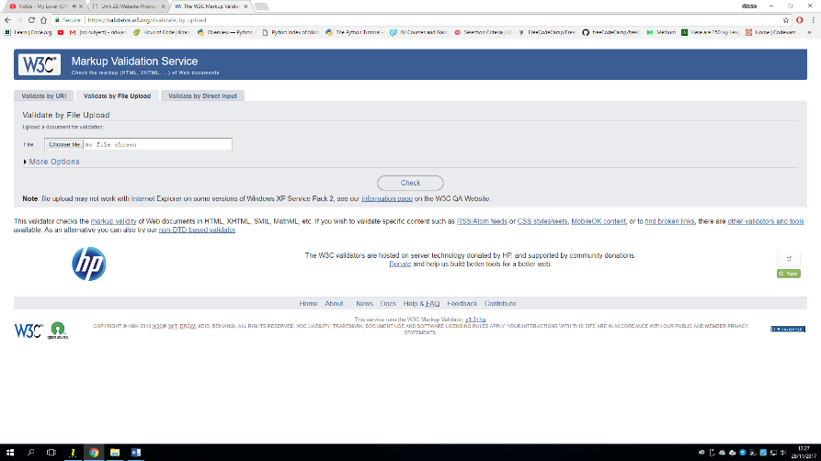

Allows you to upload your website and check its Structural validity

Another tool used when creating my portfolio is the *W3C Markup Validation Service* – which is a validation service that checks the code for my website and determines whether it follows the formatting standards set by the W3 consortium. This tool is especially helpful when publishing your website as it allows you to check for errors that may lead to your website not functioning effectively or suffer from bad traffic.

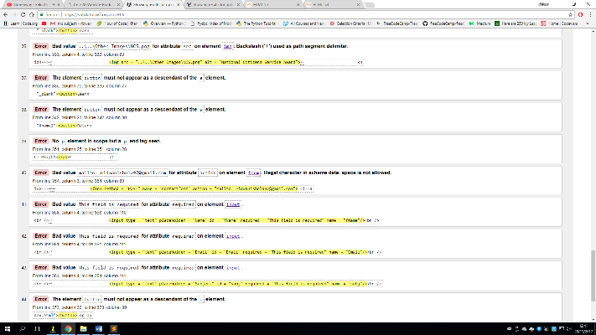

After uploading my website, 44 total errors were found by the W3C Markup Validation Service tool.

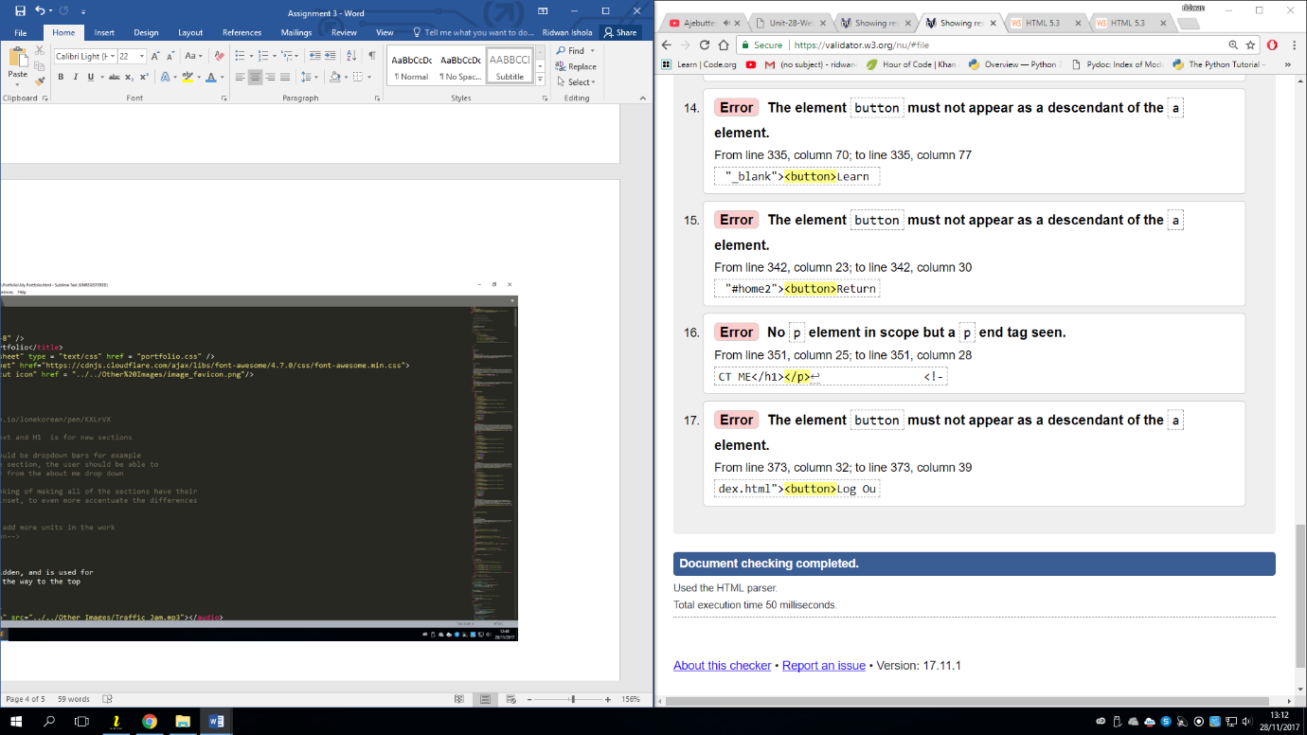After carrying out the changes recommended, I was able to reduce the amount of errors found to 17. However, decided not to carry out the rest of these changes as all but one were to do with the buttons, and if changed, will affect the *Smooth Scroll* feature of my website by preventing it from having any use. This is because this smooth scroll feature works by capturing all of the id’s in the a tags and then adding the smooth scroll feature to it.

However, when using a button, an “onclick” function is used instead of the link tag, hence the reason why I have decided not to implement the rest of the changes recommended by this service.

Nonetheless, the W3C Markup Validation Service provided some vital recommendations, in which an example is shown below:

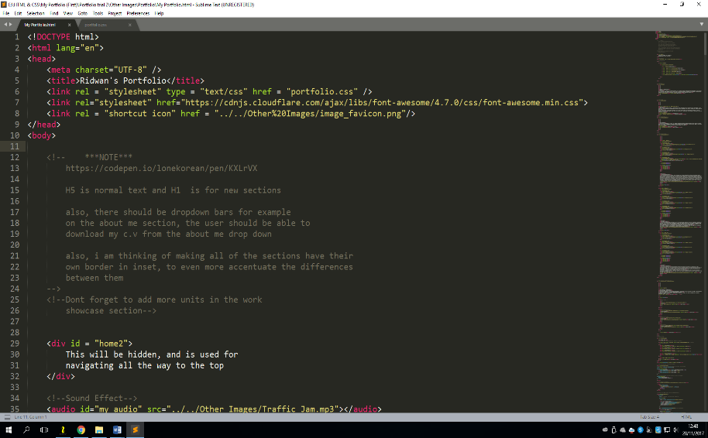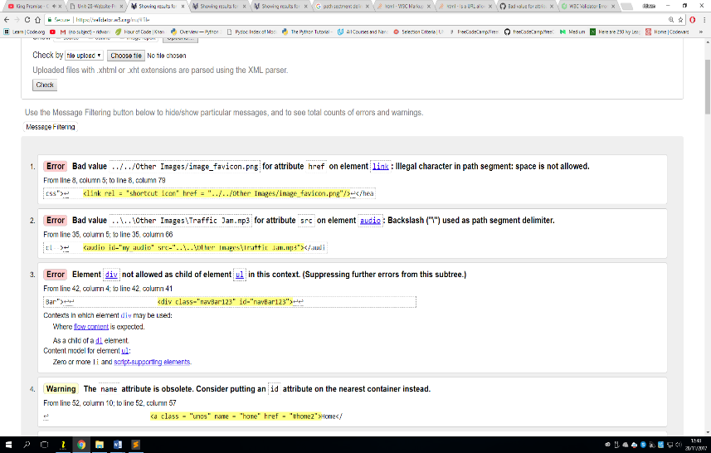**Character spacing recommendation**

One recommendation I received from the W3C validator, was on character spacing. This has to do with using spaces instead of “%20” as space is not a valid character within links. This was a useful recommendation as, if it had not been spotted, it might have resulted in broken links in my website.

Responsive Navigation Bar

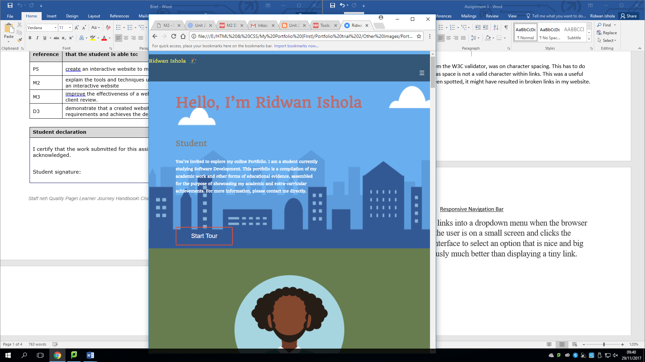

The links are converted to a dropdown icon when on small screens

One more technique I have used when creating my website was converting the regular row of links in the navigation bar, into a dropdown menu when the browser window is narrow. When the user is on a small screen and clicks the dropdown, they will get an interface to select an option that is big and easy to choose- which is a better alternative than displaying links in a smaller font that may be hard to read.

Apache Tomcat Server



As mentioned previously, I have placed my website on a server. The server I have used is the Apache Tomcat server and was useful as it allowed me to gain remote access to my portfolio from any device that has internet access. The images above show me visiting my portfolio from my mobile phone.

Accessibility on My Portfolio

* 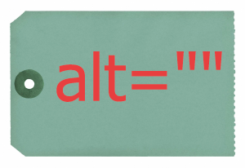Users with visual impairments: I have provided ALT text for descriptive images as it will allow screen readers to read out a verbal description of the images I have used for users with visual impairments. In addition, for users suffering from milder visual impairments- such as poor eyesight or colour blindness, I have increased the font size of the text so that it can be read more clearly. Lastly, I have increased the contrast between the text and the background-by using contrasting colours for the white text, in order to enhance the visibility of the text; therefore increasing the user’s access to information as it will enable the user to read the text more effectively.

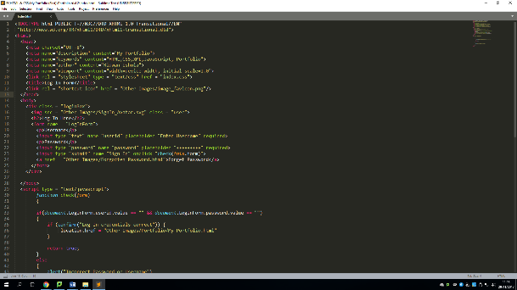

* Users with cognitive impairments: To cater for users with cognitive impairments, I have used large headings for all of my titles- in order to increase its readability. Furthermore, I have used simple, clear and concise language in order to make the content of my page more understandable.
* 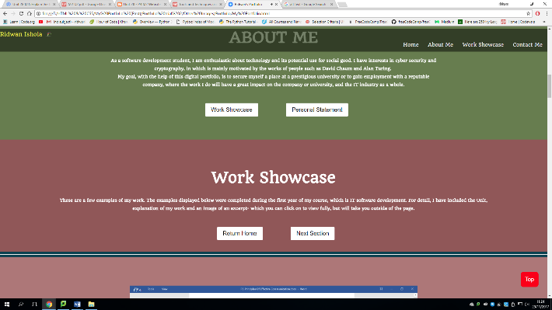Users with mobility impairments: I have improved the access to information that users with mobility impairments have by ensuring that there is a link that directs the users of my portfolio, directly to the parts of my web-page. In addition, I have made my navigation bar ‘fixed- meaning its position doesn’t change- improving the ease of navigation through my portfolio as the users could click directly to the parts of my website that they are trying to visit.

Other Applications Used

The text editors used to create my website were Sublime text and Notepad++. I found Sublime Text especially useful as it automatically creates the closing tags for each of the elements you use when you press enter.

How My Website Meets the Defined Requirements and Achieves the Defined Purpose as Described in the Scenario

My website achieves all of the purposes described in the scenario. Firstly, as my website as more than 5 pages that include: Home, About Me, Work Showcase, Extra-Curricular Activities and a Contact Me page. My portfolio also contains information about me such as my personal statement, C.V and Contact Details.

Additionally, my website meets the defined requires as all of the pages link with each other and the homepage. Furthermore, I have used CSS to makes changes to the look and feel of my website through an external stylesheet.

Lastly, my portfolio has a login page to validate the login to the website and a form to collect feedback from the users of the website.

Overall, I believe that my portfolio has met all of the requirements outlined in the scenario, therefore fit-for-purpose.

Improve the effectiveness of a website on the basis of a client review.

**Review 1- From Jamie Foster (Classmate)**



Double-click to open

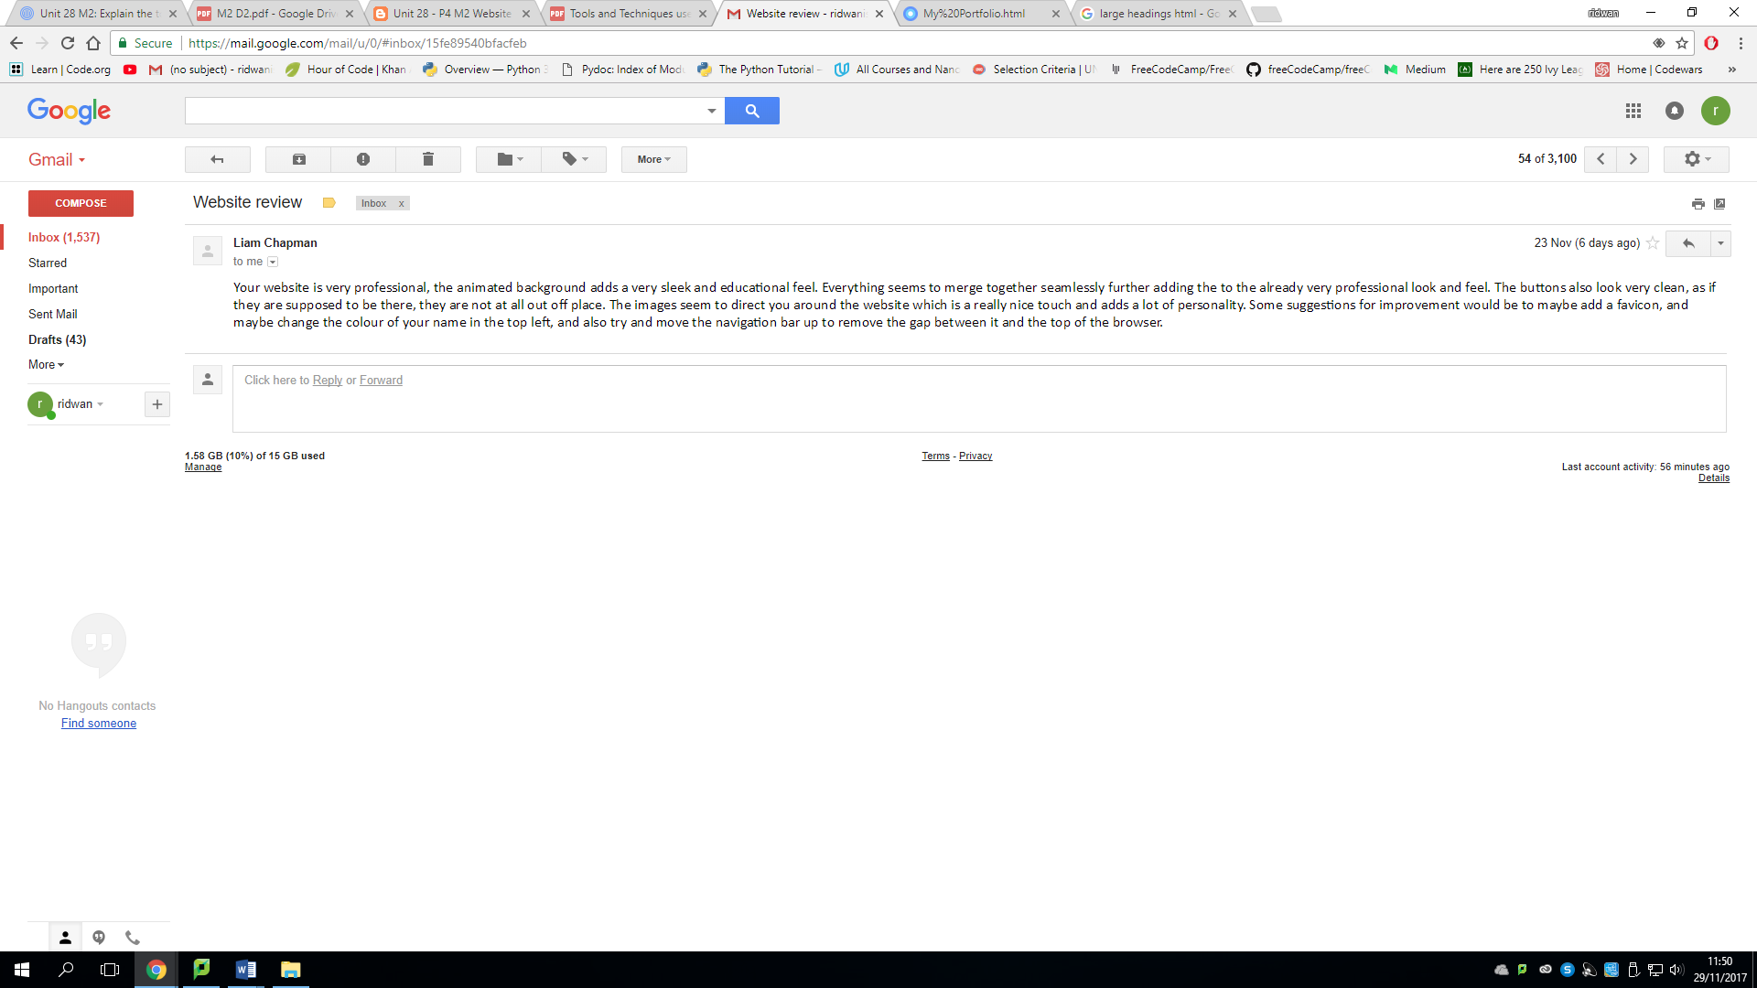**Review 2- From Liam Chapman (Classmate)**

**Content**

“*Your website is very professional, the animated background adds a very sleek and educational feel. Everything seems to merge together seamlessly further adding to the already very professional look and feel. The buttons also look very clean, as if they are supposed to be there, they are not at all out off place. The images seem to direct you around the website which is a really nice touch and adds a lot of personality. Some suggestions for improvement would be to maybe add a favicon, and maybe change the colour of your name in the top left, and also try and move the navigation bar up to remove the gap between it and the top of the browser.* ”

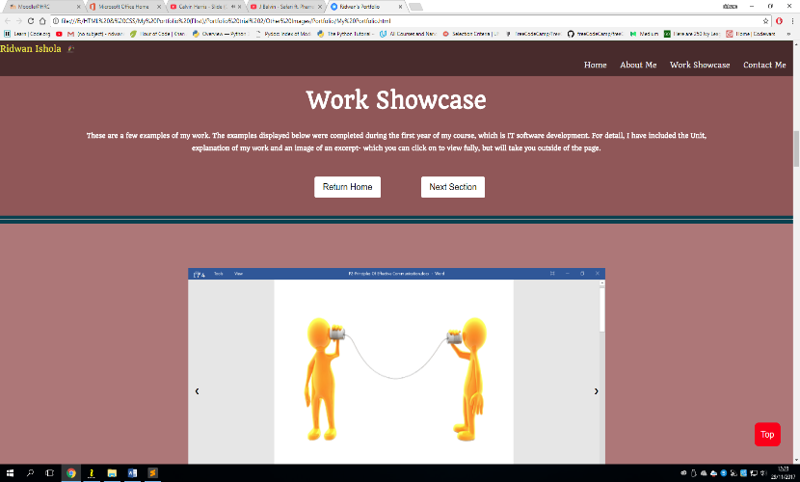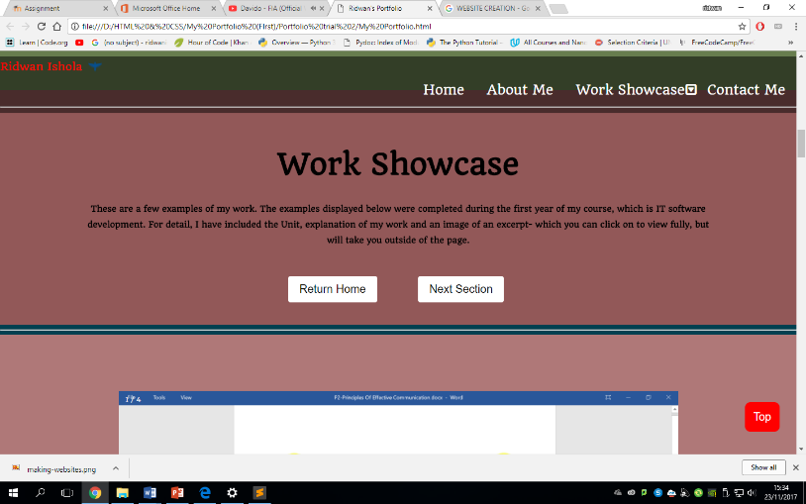

Before Changes

After Changes

As you can see from the above images, I have implemented the changes that were recommended by my classmate. One change that can be seen immediately, is the font colour, which has been changed to white from black. I have chosen to implement this change into my website as it will enhance the contrast between the text and background, therefore increase its readability.

Another change I have made is in accordance to the changes that was recommended to me by Liam, which is to change the gap between my navigation bar and browser. I have achieved this by removing the padding top of the navigation bar and changing it from 10px to 0.

Overall, it is important to get feedback and make improvements as it will allow performance to be improved. In terms of my portfolio, it was important for me to get feedback and improve my website as it will make it more likely to achieve its purpose. In addition, it will be more effective when used to support my future aspirations- whether to gain employment or attend university.